**IN3005 Computer Graphics**

**Coursework Report**

**Tayyab Hussain**

Description of the game:

Annotated Screenshot of top-down view:

KBM Controls:

Asset Listings:

URL: Date of Download: License:

Reflection: (PUT THIS RIGHT AT THE BOTTOM)

***Route and Camera***

Route:

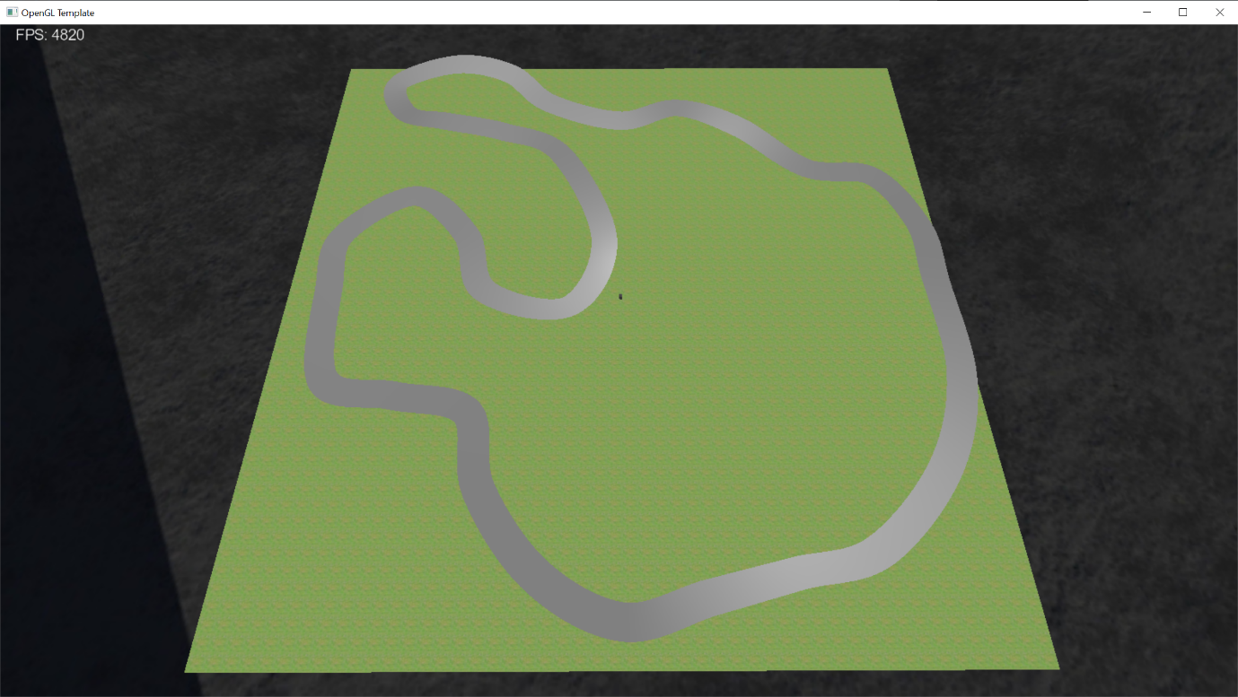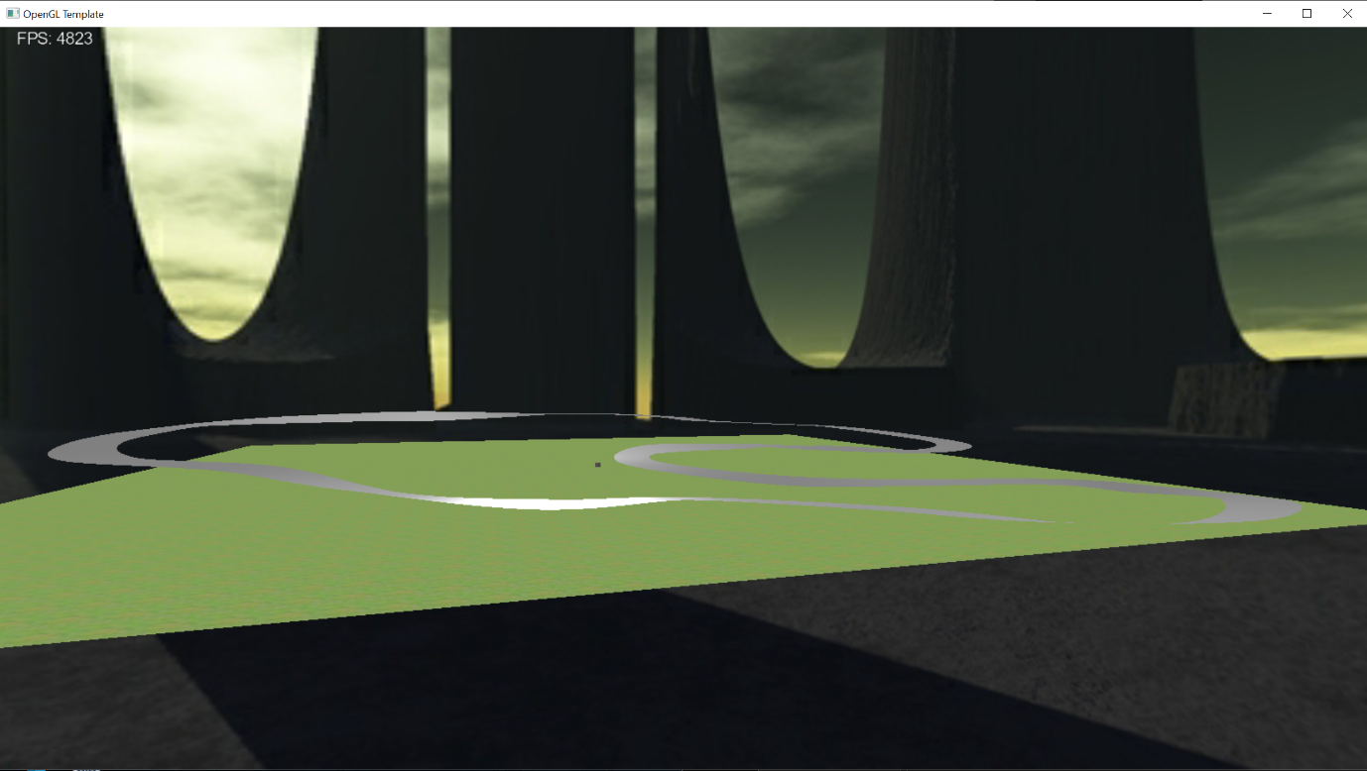This is the track I have created for my game. I implemented it using the Catmull-Rom spline. There are 33 points along the track, each with its own individual up-vector to create banked or off-camber corners.

After applying a texture to it, here is what the track looks like now: 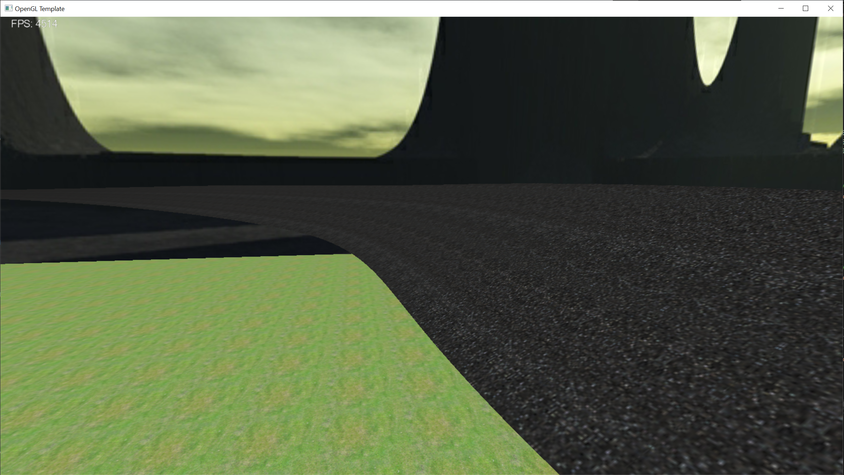

I added height-mapped terrain though it is very rudimentary. I designed it using Microsoft Paint 3D, so it doesn’t blend in well. I’m hoping that once I add some more meshes I can hide the rough edges of my heightmap.

I then placed my Tunnel primitive in 2 locations along the track and used a Catmull-Rom spline again to create 2 barricades on either side of the track. The barricades use the offset points (that create the track width) and a TNB frame from each of these points to position a new point above the current offset point in the direction of the centre line`s up vector.

I did have a few issues with the texturing of the barricades. Since both the track and the barricades had different textures, but they were part of the same class, only one texture would be applied to both objects. I could not find an elegant solution to this problem. I could’ve simply not applied a texture to the track or barricade, but I didn’t like how this looked. So instead, I created a new Catmull-Rom spline class and renamed it BarricadeSpline. This class is identical to the original in every way except that it doesn’t render anything other than the barricades and therefore I can use the main Catmull-Rom class to render that track and track texture and the barricade class to render the barricades and barricade texture.

This is what the track looks like as of now:

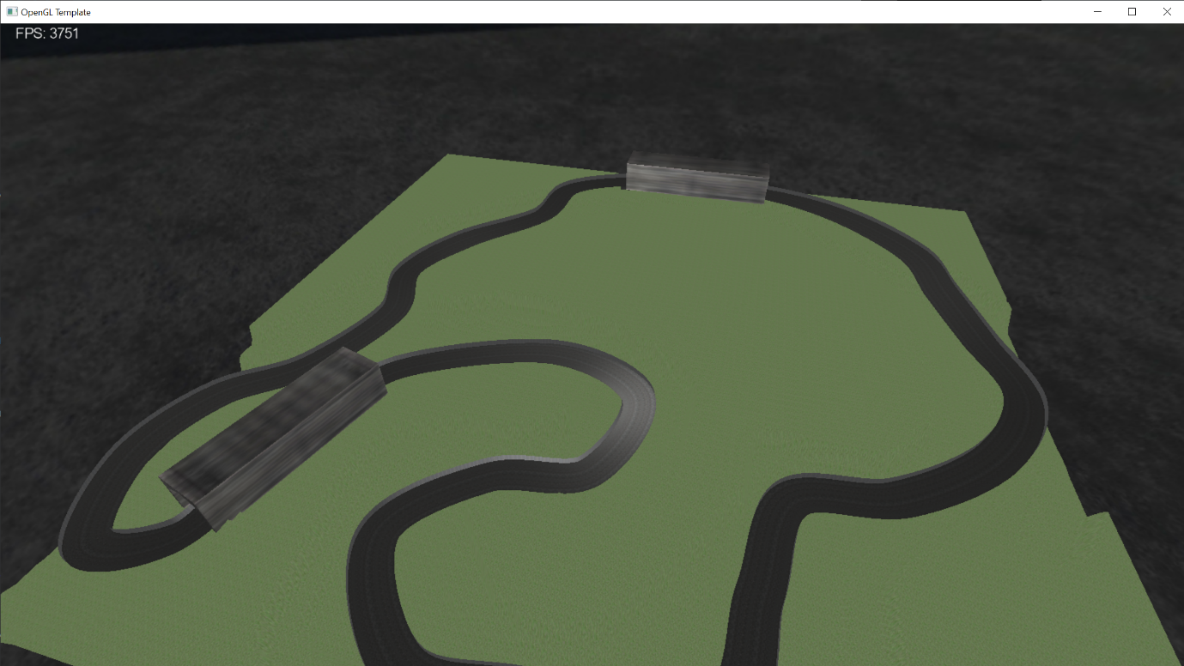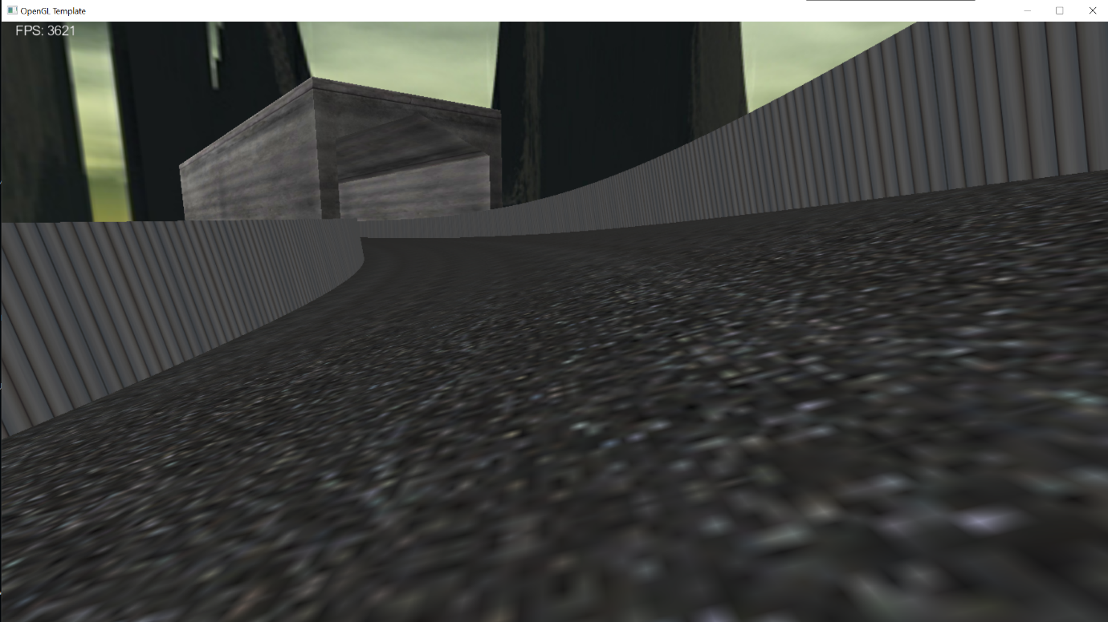

I also changed the skybox at this stage, to match the theme of my game more closely. This was the outcome: 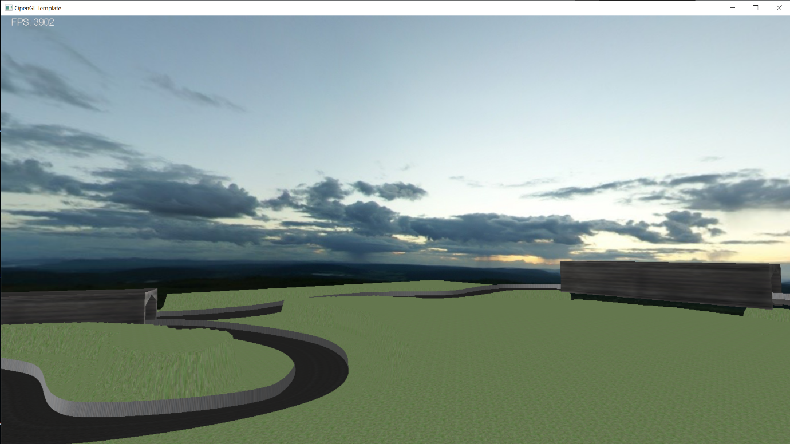

Camera:

The 2 camera modes I decided to add to my game were third-person and first-person. I have implemented keyboard controls to change between these 2 camera modes and the free-view camera (This has been detailed above).

The way I implemented this is by first adding a mesh(player car) to my game and specifying its position and orientation using a TNB frame calculated from the track spline. I then set the cameras relative to the player’s car, e.g. behind and above the car for the third-person camera. In terms of the keyboard controls, I used 3 boolean values for each of the cameras, third-person, first-person and free-view. In the code, once the corresponding key was pressed, I would set the related boolean value to true and set the others to false. Then in the update() method, the code checks to see which boolean is set to true and sets the camera accordingly.

These are what the 2 camera modes look like in my game: 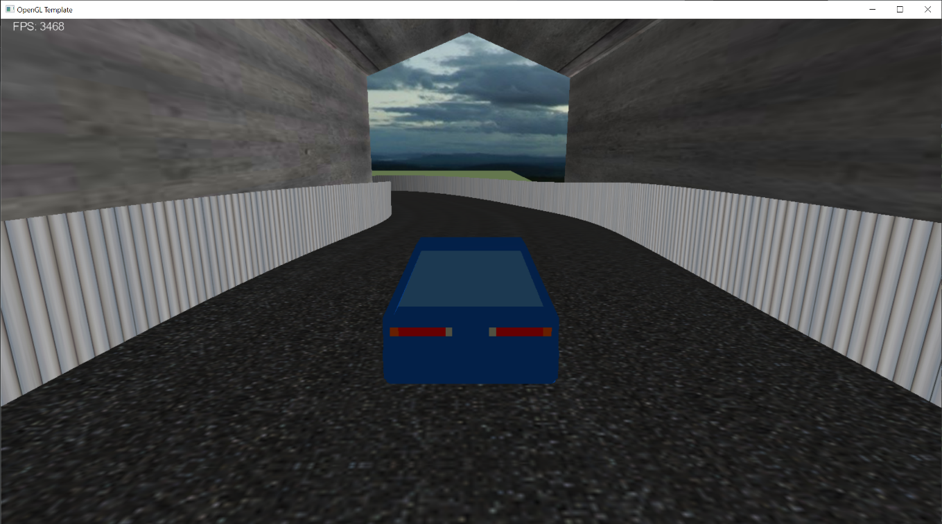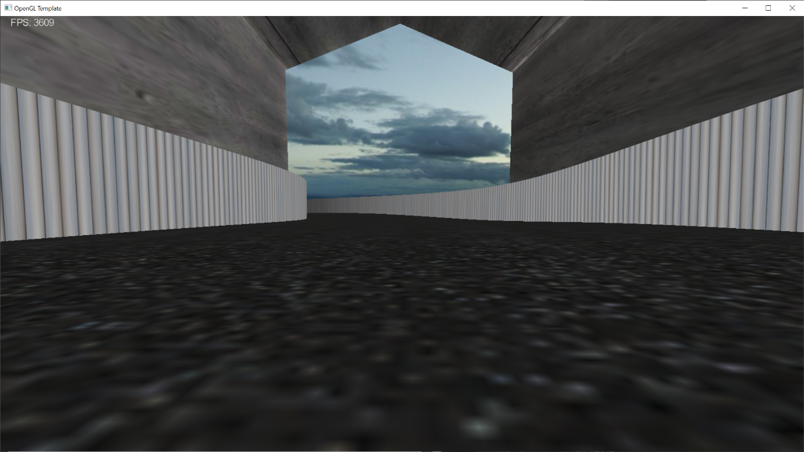

***Basic Objects, Meshes and Lighting***

The first basic object I have designed is a tunnel. The tunnel is defined in its own class and has its vertex attributes pushed into a vertex buffer object or VBO. The tunnel object also has its own shader program which applies the Phong lighting model. The lighting is calculated per-fragment as opposed to per-vertex as this results in higher quality shading. Also, within the fragment shader, I have mixed the colour of my object, which was stored in the VBO, with the texel colour. This allows me to have a bit more control over how the final texture of my object looks.

Putting all this together, here is what my object looks like: 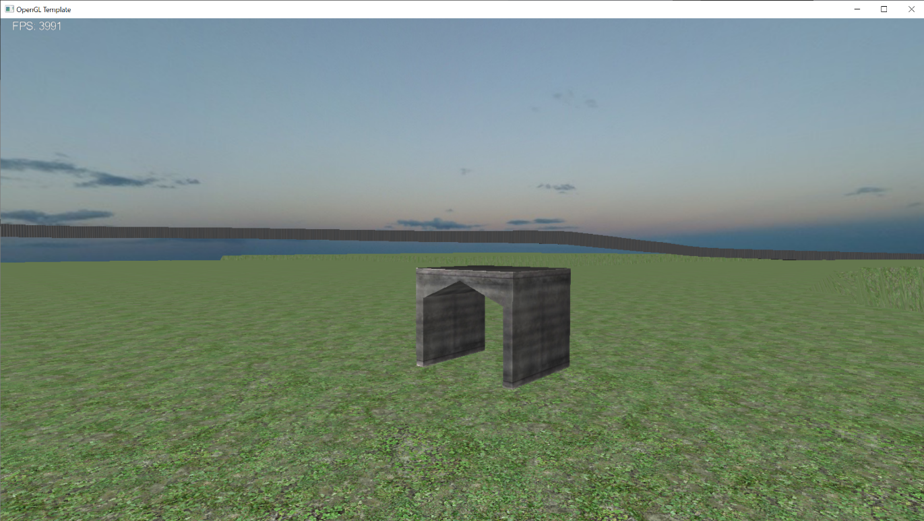

After placing 2 transformed instances of my object into the game, here is what it looks like now: 